Design Document Generator
Access the application here:
https://design-document-converter.azurewebsites.net/

1.0 How to Generate Design Document using the app
This section explains how to generate a Design Document using the application. The application converts a Design Document presentation slide deck (.pptx) into a comprehensive and formal Microsoft Word Solution Design Document (.docx).
Users are required to upload the PowerPoint file along with the client's logo image. The client's logo ensures that the generated Design Document follows the original template, where the client's branding (in addition to the Enfrasys logo) is displayed on the cover page and in the document header.
Here are the supported files for the upload:
File Type | Supported Format
Input – Design Document Presentation | .pptx
Input – Client Logo | .png, .jpg, .jpeg,
Output – Generated Design Document | .docx

Important notes to consider when preparing the PPTX slides before uploading, to ensure the best possible output:
- Ensure that all unused or hidden slides are removed, and that all remaining slides are visible.
- Arrange the slides in the correct presentation order before uploading.
- Adding Presenter Notes is highly recommended, as it helps the AI better understand the context and intent of each slide.
- If any architecture or flow diagrams are drawn directly using PowerPoint shapes within the .pptx slides, take a screenshot of the diagram and insert it as an image into the slide instead.
Follow the steps below to generate your Design Document.

Step 1: Upload the PPTX Design Document and Client’s Logo
Upon entering the application, you will be directed to the Generate page.
Follow the steps below to upload the required files:
- In the Drag & drop your PPTX file here area, click Browse Files or drag and drop your Design Document (.pptx) into the uploaded area.
- In the Upload Client Logo section, click Select to choose the client’s logo image. Supported formats are .png, .jpg, and .jpeg.
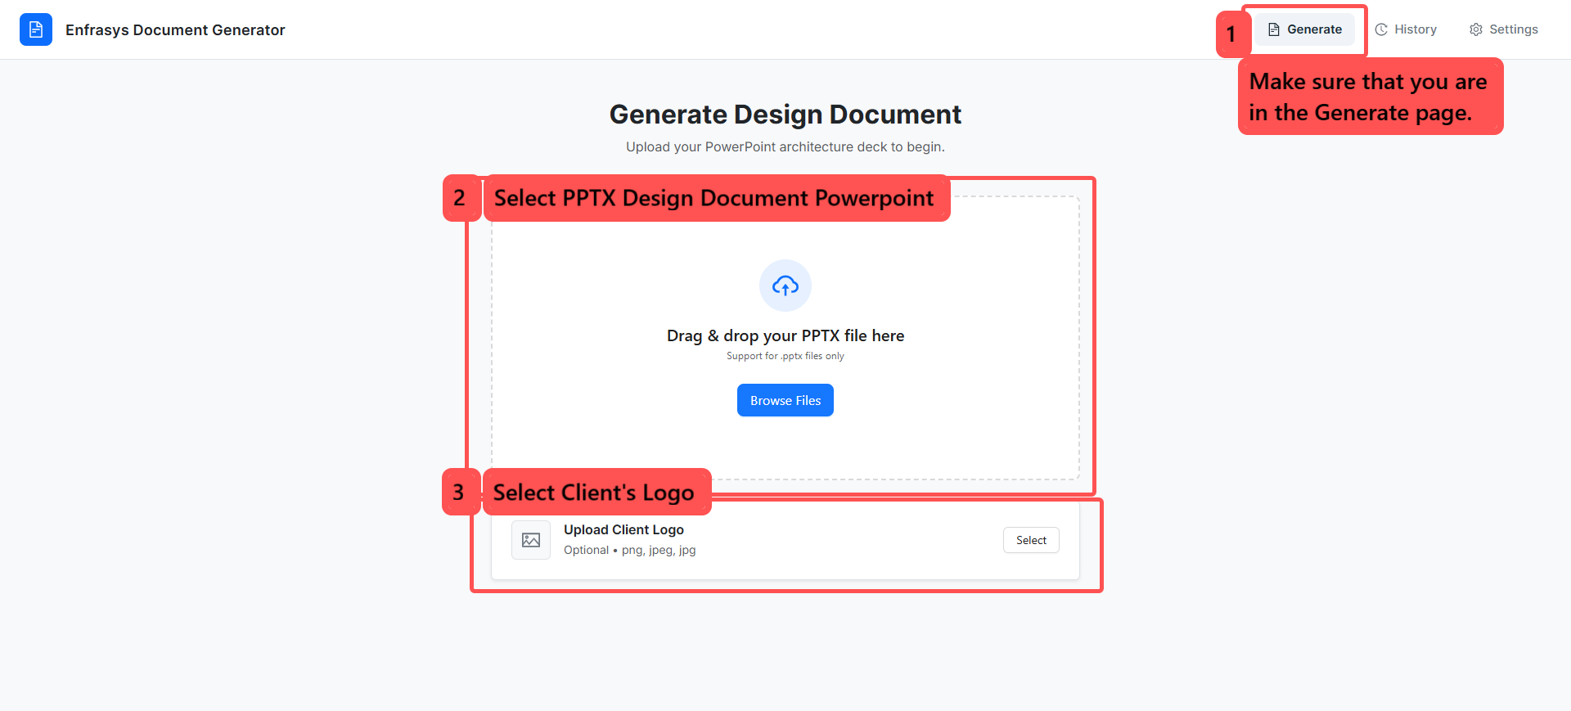
Once both the PowerPoint file and client logo have been uploaded successfully, click Next: Preview Slides to proceed to the next step.
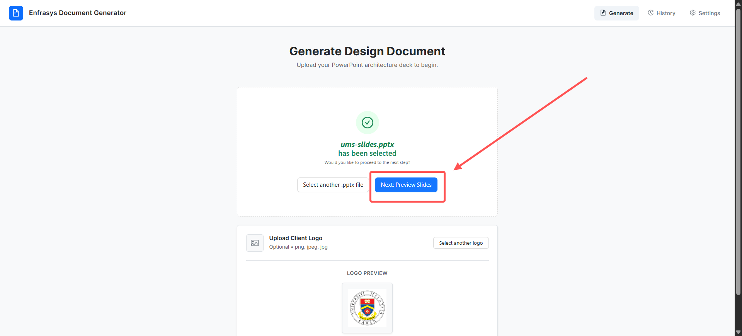

Step 2: Preview Slides and Add AI Insights
After clicking Next: Preview Slides, you will be redirected to the Slide Preview page. This page displays a preview of all extracted slides along with their corresponding presenter notes.
Review each slide and its presenter notes to ensure that all content has been extracted correctly before proceeding.
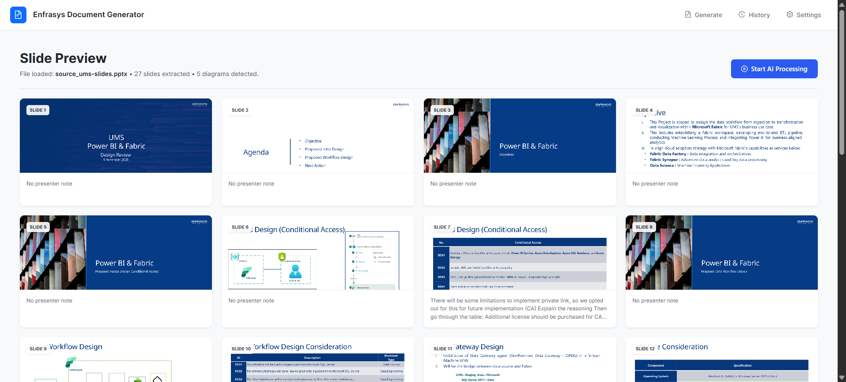
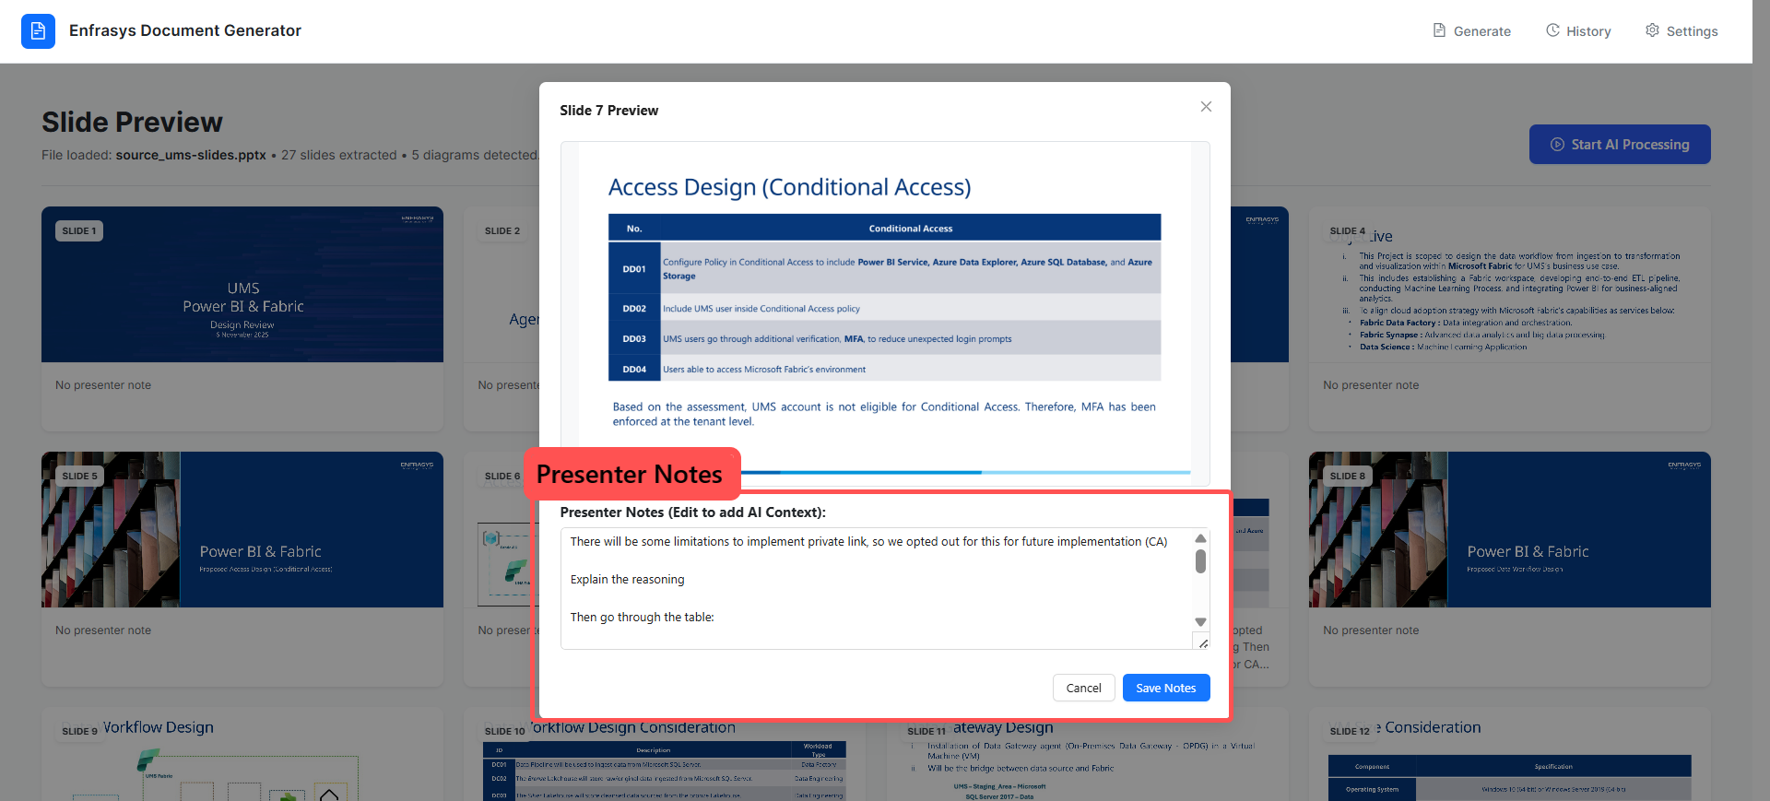

You can also click on any individual slide to add additional context or instructions for the AI, especially for slides that contain diagrams, images, or minimal text.
To add or edit AI context:
- Click on the slide you would like to add context to.
- Enter the additional context or instructions in the Presenter Notes (Edit to add AI Context) field.
- Click Save Notes to apply the changes
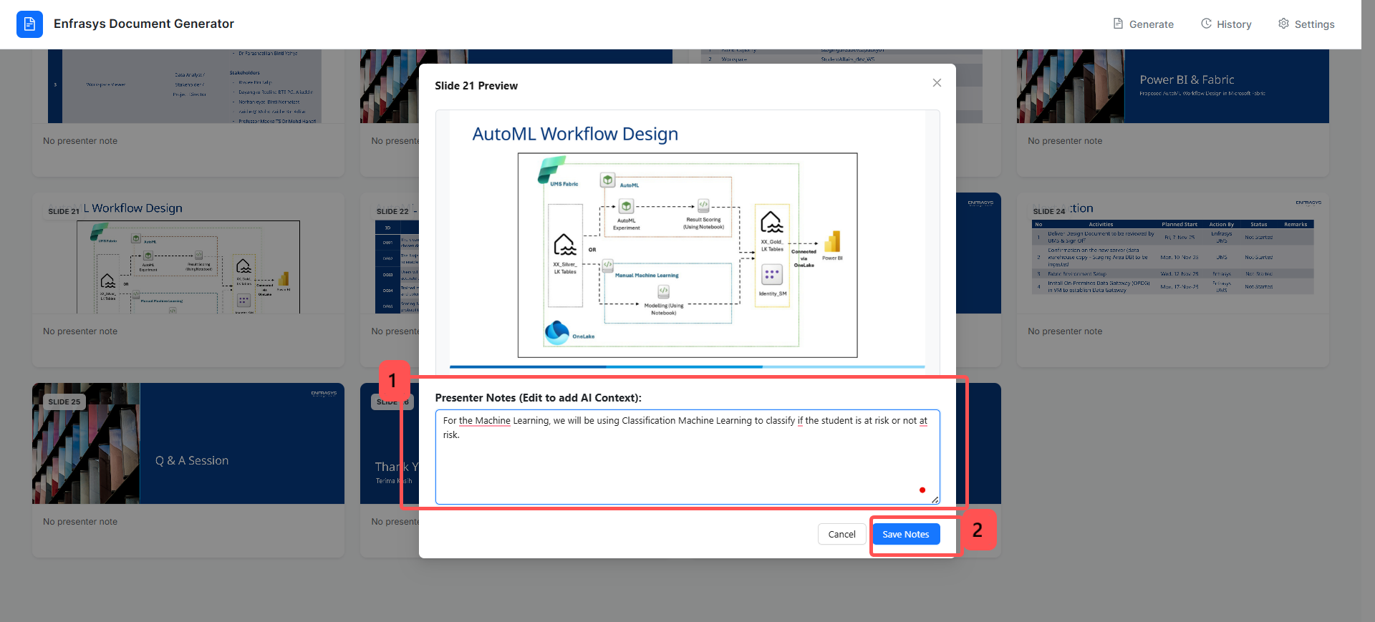
After reviewing all slides and adding AI context where necessary, proceed to the next step by clicking Start AI Processing.
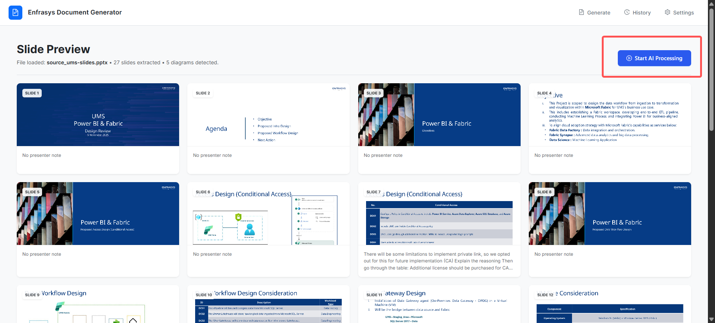

Step 3: Start AI Processing
After clicking Start AI Processing, you will be redirected to the Processing Page. This page displays a progress indicator showing the AI’s current processing status while the document is being generated.
The processing typically involves the following stages:
- Extracting Content and Images
- Analyzing Architecture Diagrams via Vision AI.
- Orchestrating Document Structure
- Drafting Markdown Sections
- Finalizing Word Document Format.
Depending on the length and complexity of your presentation, this process may take approximately 3-5 minutes to complete.
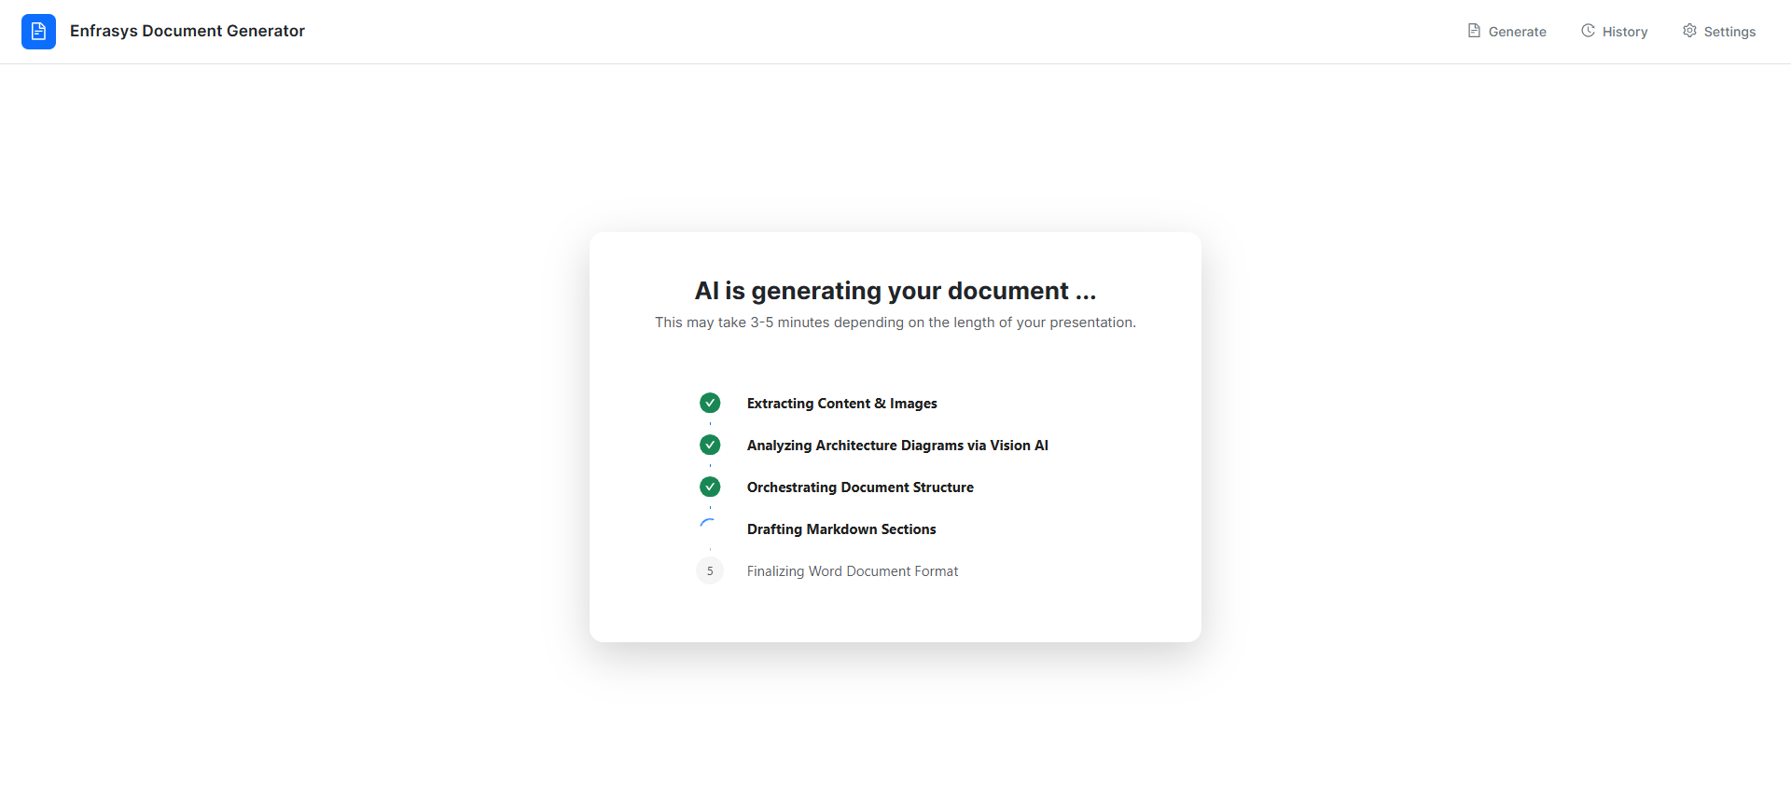
Once the processing is complete, click Preview Generated Document to proceed to the next step.
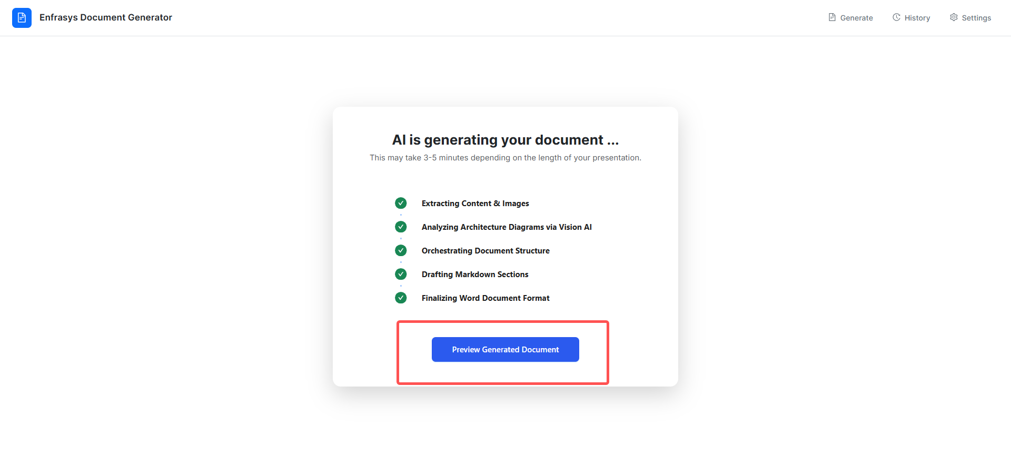

Step 4: Preview, Rename, and Download the Generated Document
After clicking Preview Generated Document, you will be redirected to the Review page.
On this page, you can:
- Preview the generated document content.
- Rename the generated file name before downloading.
- View the estimated generation cost, which is dynamically calculated based on the pricing values configured in the Settings page.
- Download the generated Design Document in .docx format.
Note: The document preview shown in the Review page is rendered using LibreOffice for display purposes only. The actual download .docx file will follow the full Enfrasys template design and formatting.
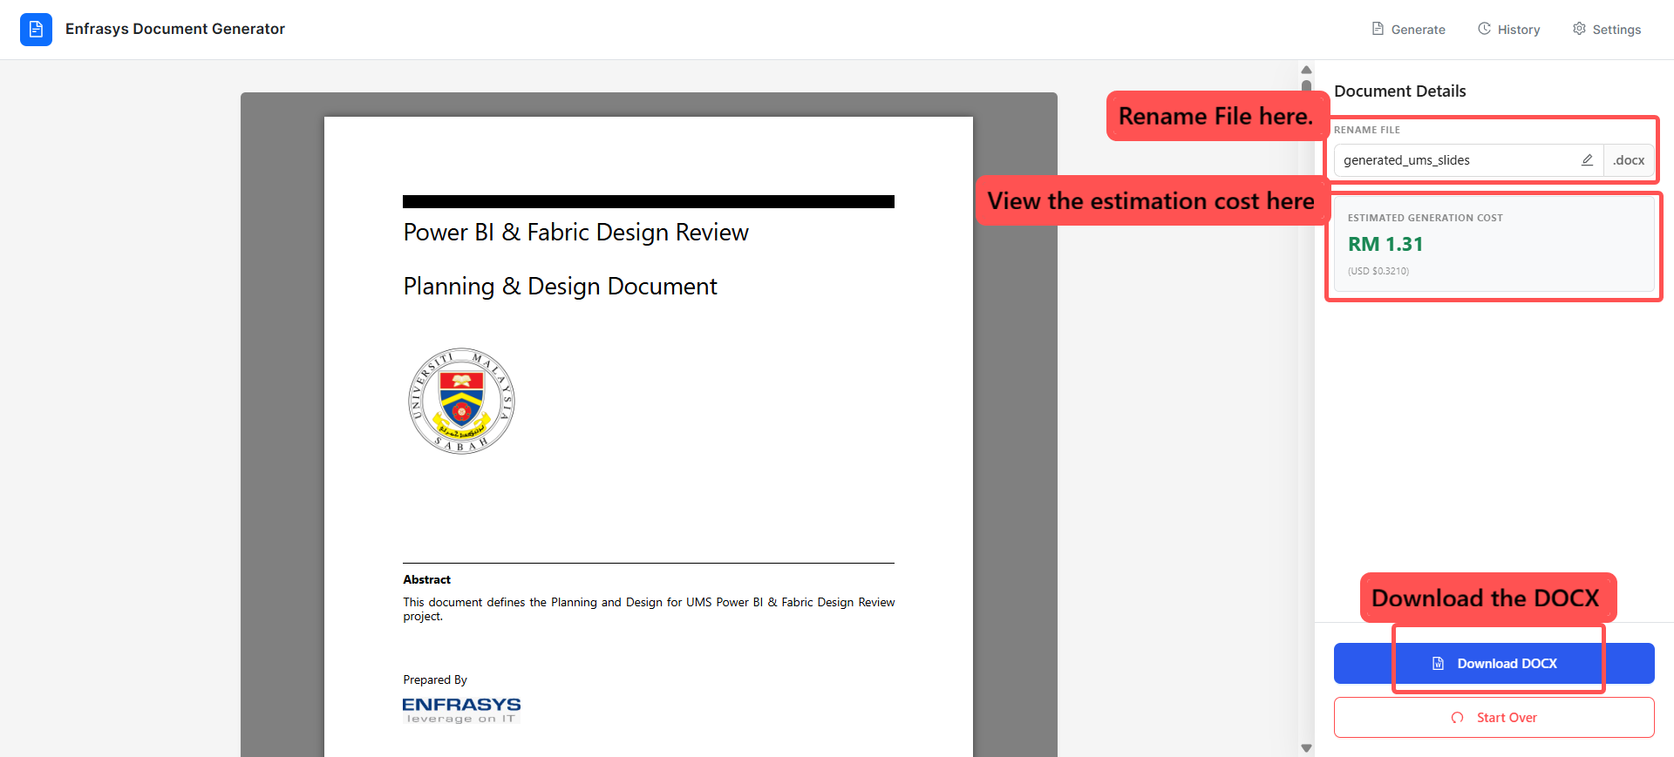
If you would like to generate a new document, click Start Over located at the bottom of the sidebar. This will return you to the Generate page to begin a new generation process.
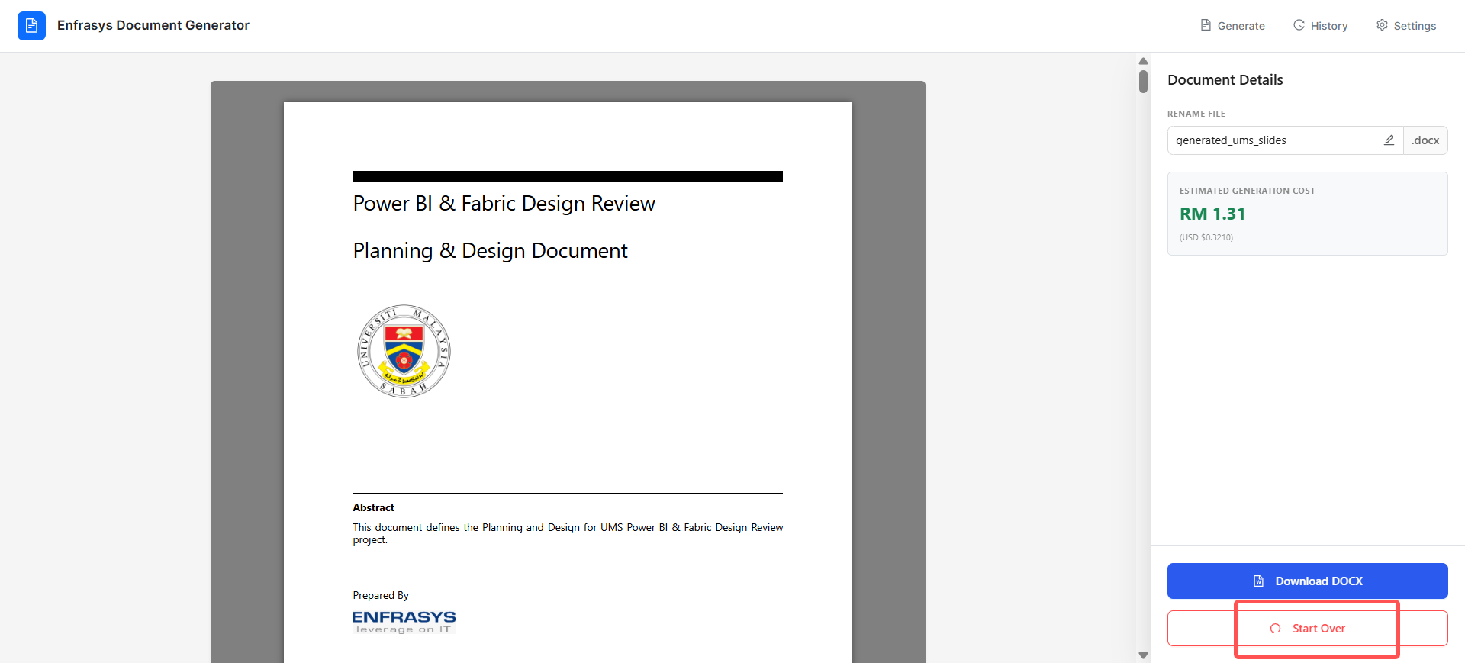

2.0 Managing Generation History
This section explains how to view, download and delete previously generated documents from the History page. Each generation task is tracked in Cosmos DB (metadata) and its output file is stored in Blob Storage (the actual document).
Follow the steps below to manage your generation history.

Step 1: Navigate to the history page
From the application header, click History in the upper-right corner of the page. You will be redirected to the Generation History page.
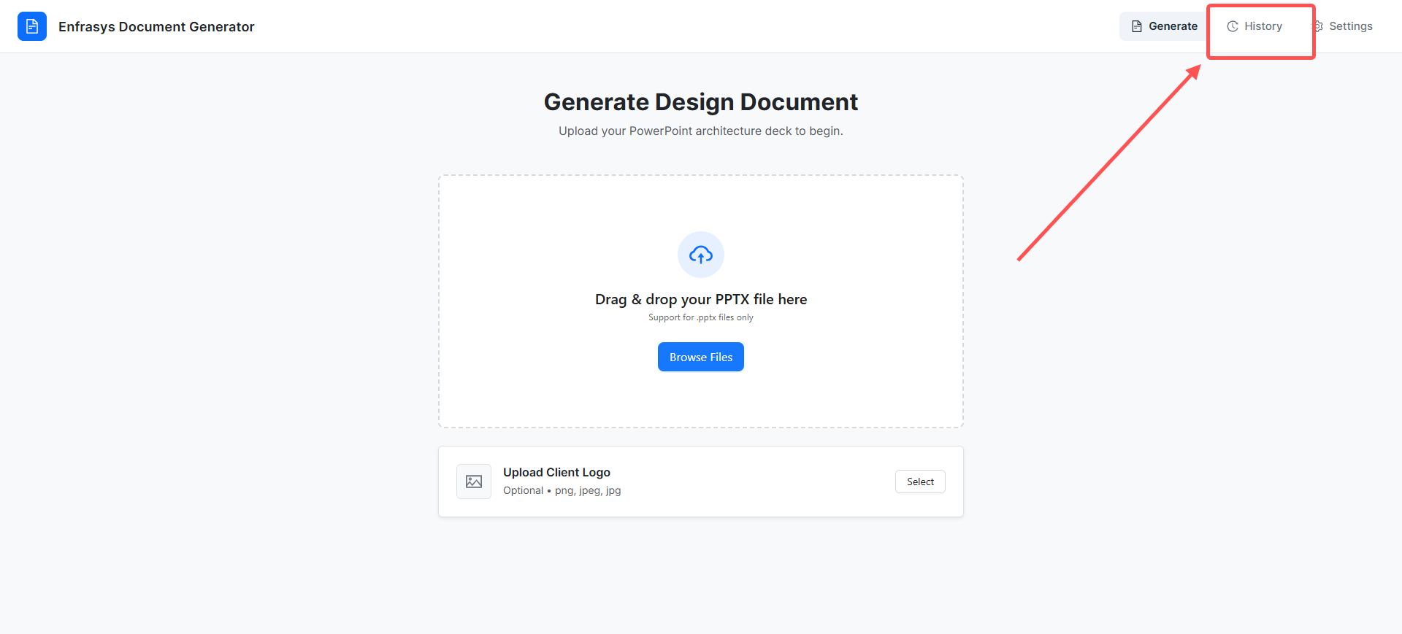

The Generation History page displays a list of previously generated documents. The table includes information such as the document name, document type, generation date and time, generation status, and estimated generation cost.
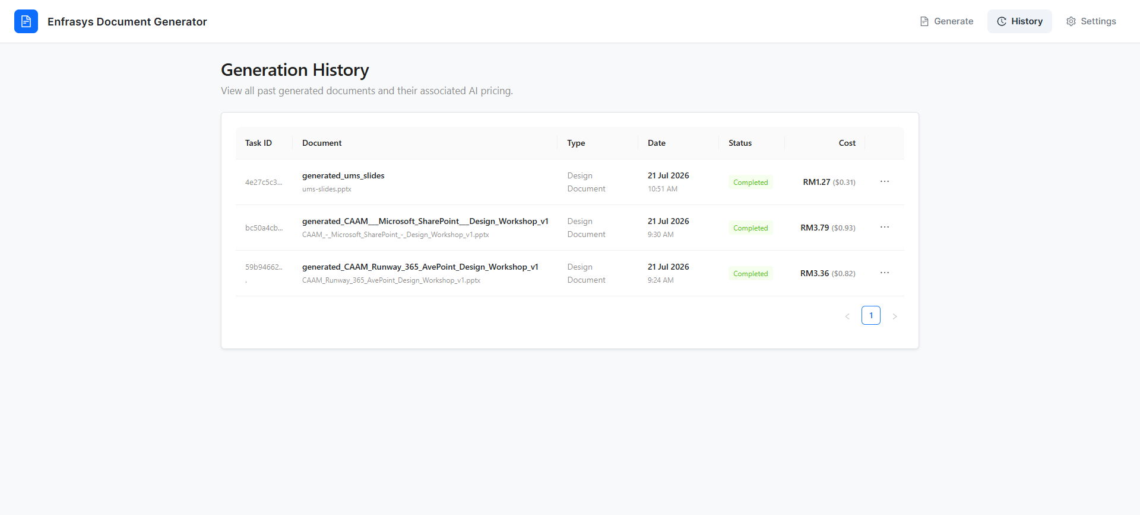

Step 2: View Previously Generated Document
Once a document has been generated, its metadata is stored in Cosmos DB, while the generated document is stored in Azure Blob Storage.
To view a previously generated document, click the three-dot menu on the right side of the corresponding row and select View Document.
The document will open in the preview page, where you can review the generated content before downloading it.
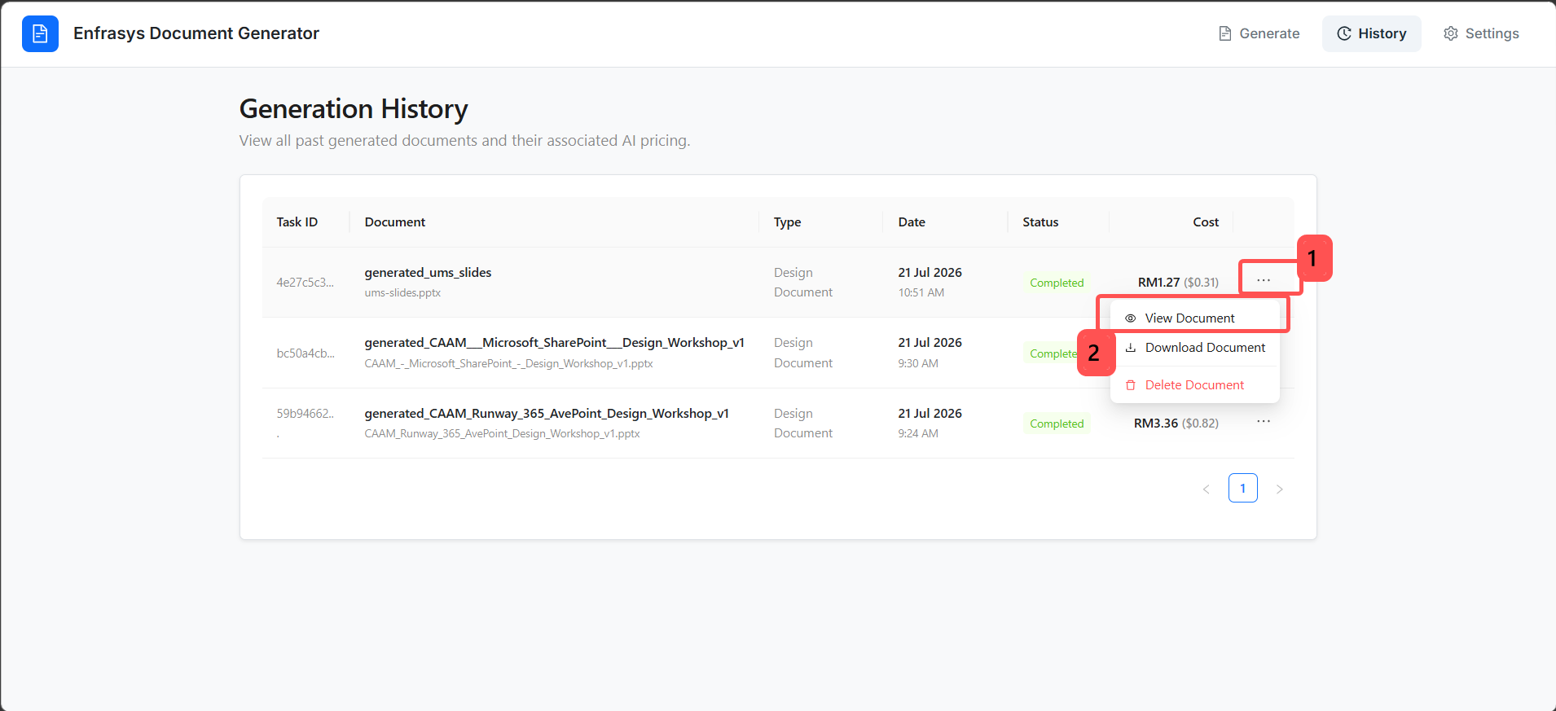
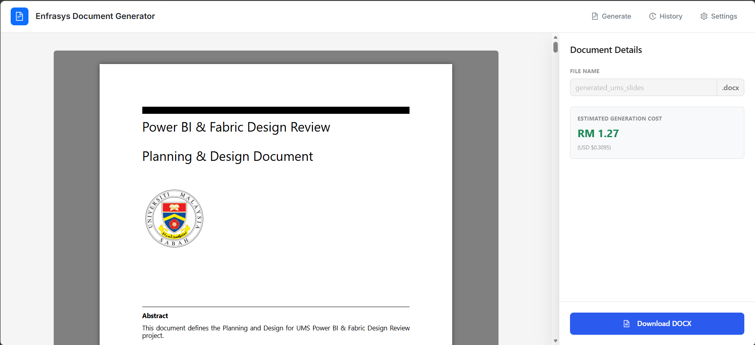

Step 3: Download Previously Generated Document
Previously generated documents can be downloaded either from the document preview page or directly from the Generation History page.
Follow the steps below to download a previously generated document.
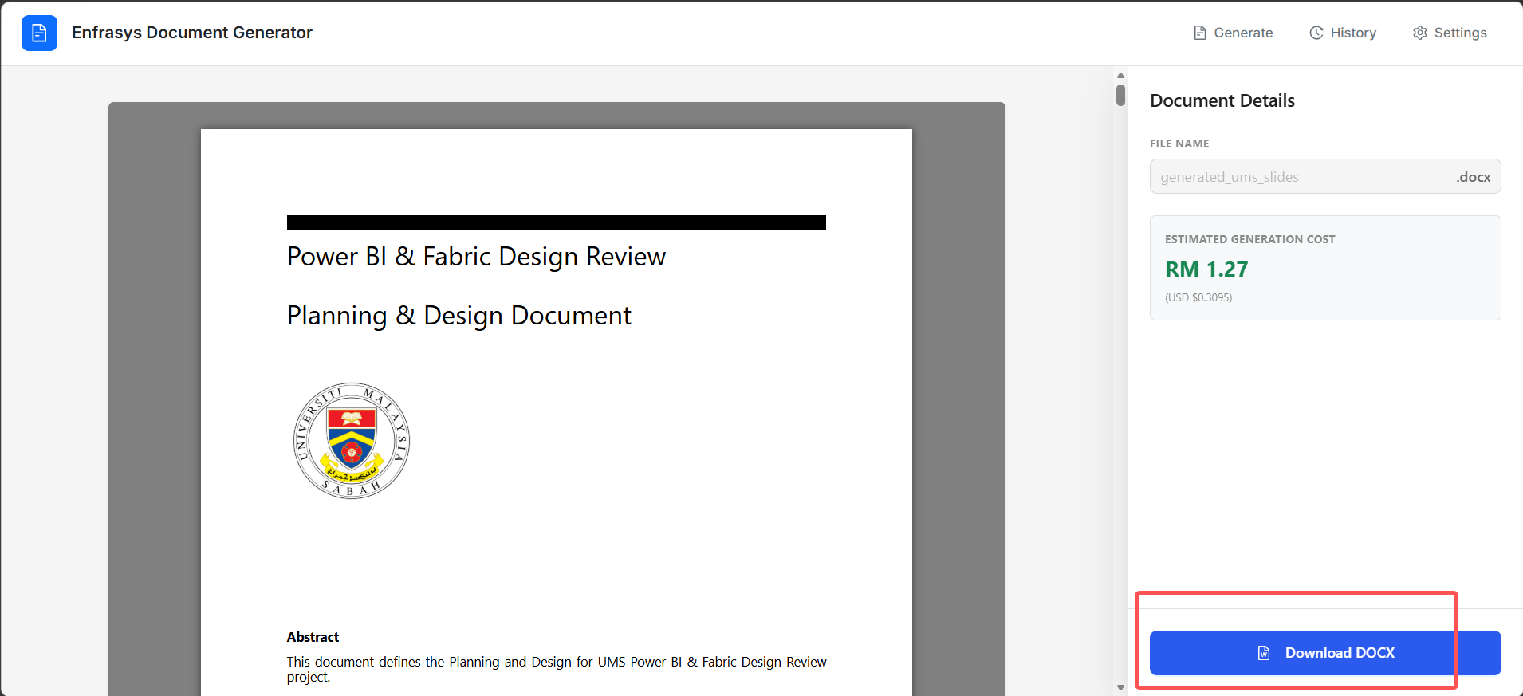
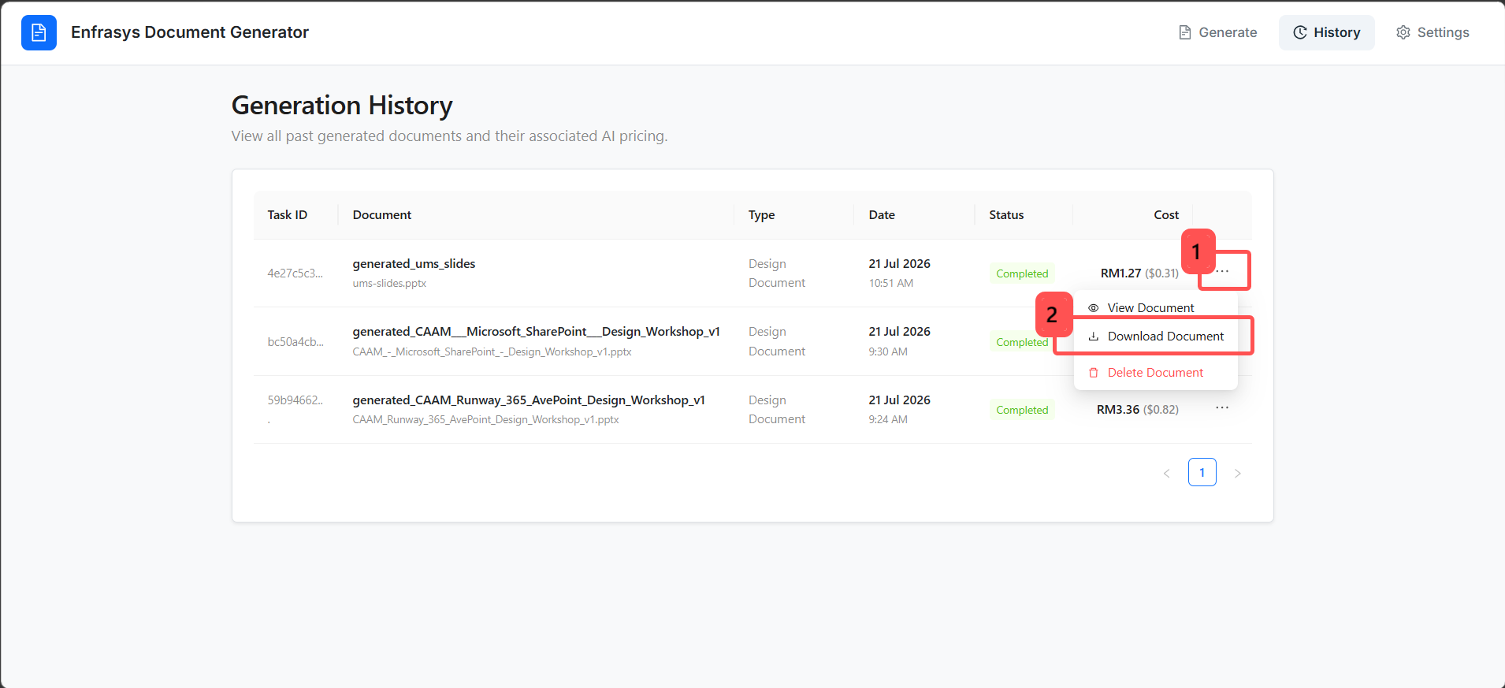

Step 4: Delete Previously Generated Document
If a generated document is no longer required, you can delete it from the Generation History page.
Deleting a document removes its metadata from Cosmos DB and permanently removes the associated file from Azure Blob Storage.
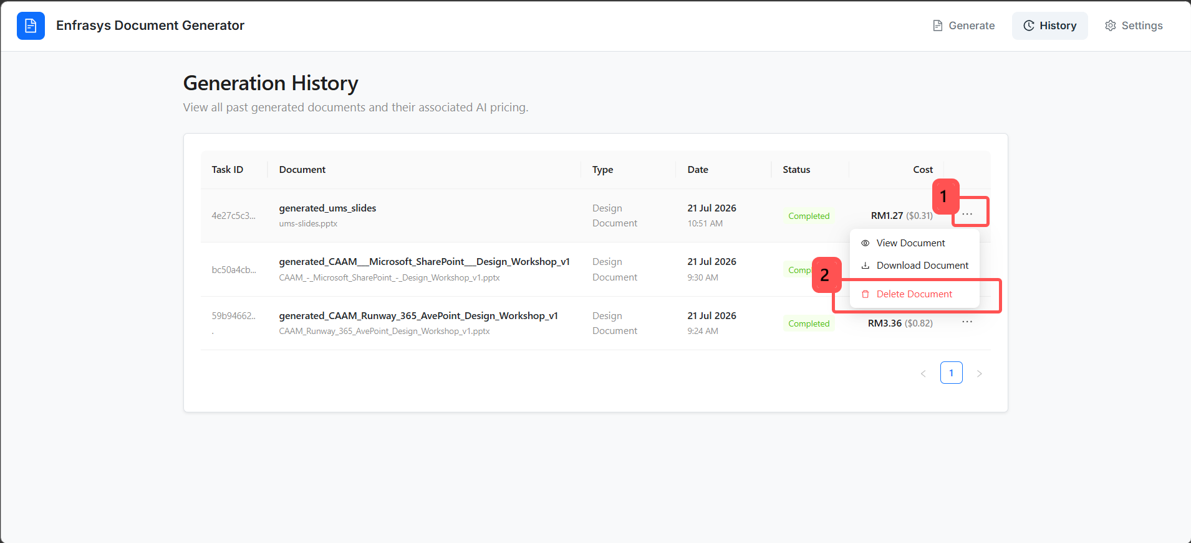
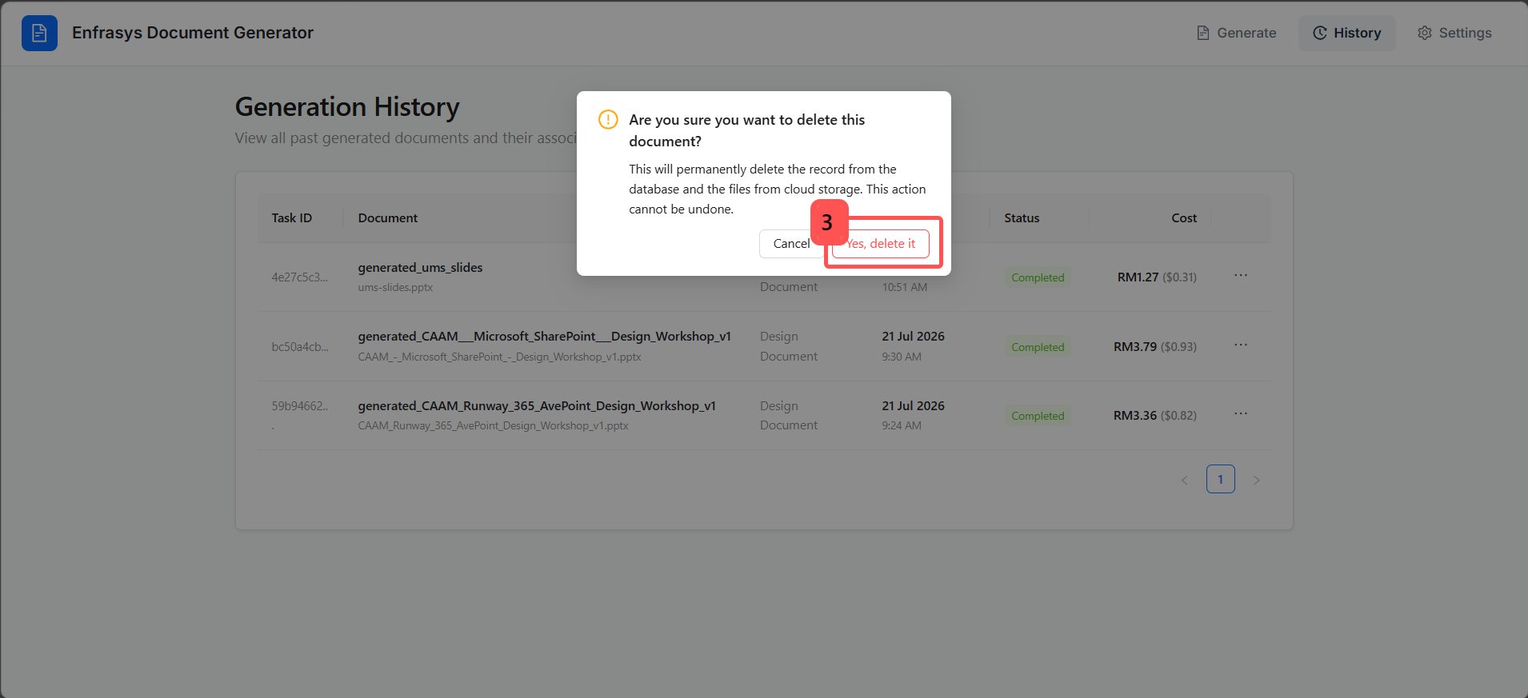

3.0 Configuring AI Pricing Settings
This section explains how to configure the AI service pricing rates used to estimate the generation cost of each design document.
The Settings page allows you to configure the currency exchange rate, AI model pricing (Vision and LLM), and Azure Content Understanding pricing. Any changes made will be reflected immediately in the cost estimates displayed on both the Review page and the Settings page.
Follow the steps below to configure your AI pricing settings.

Step 1: Navigate to the Settings Page
From the application header, click Settings in the upper-right corner of the page. You will be redirected to the Settings page.
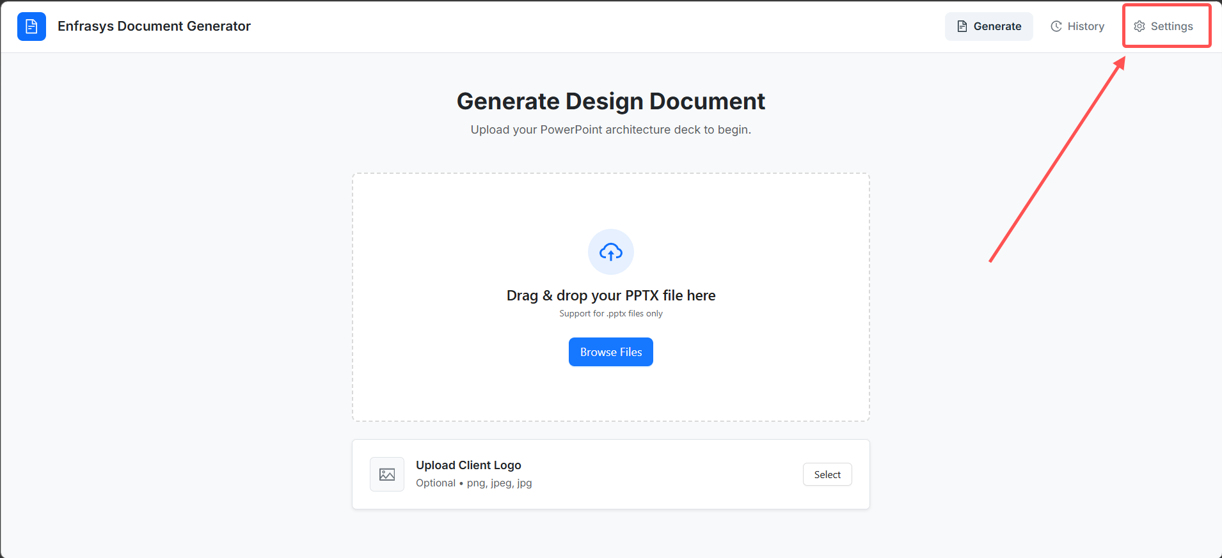

The Settings page contains three configuration sections:
- Currency Conversion
- AI Model Pricing (USD)
- Azure Service Pricing (USD)
These sections allow you to configure the pricing parameters used for document generation cost estimation.
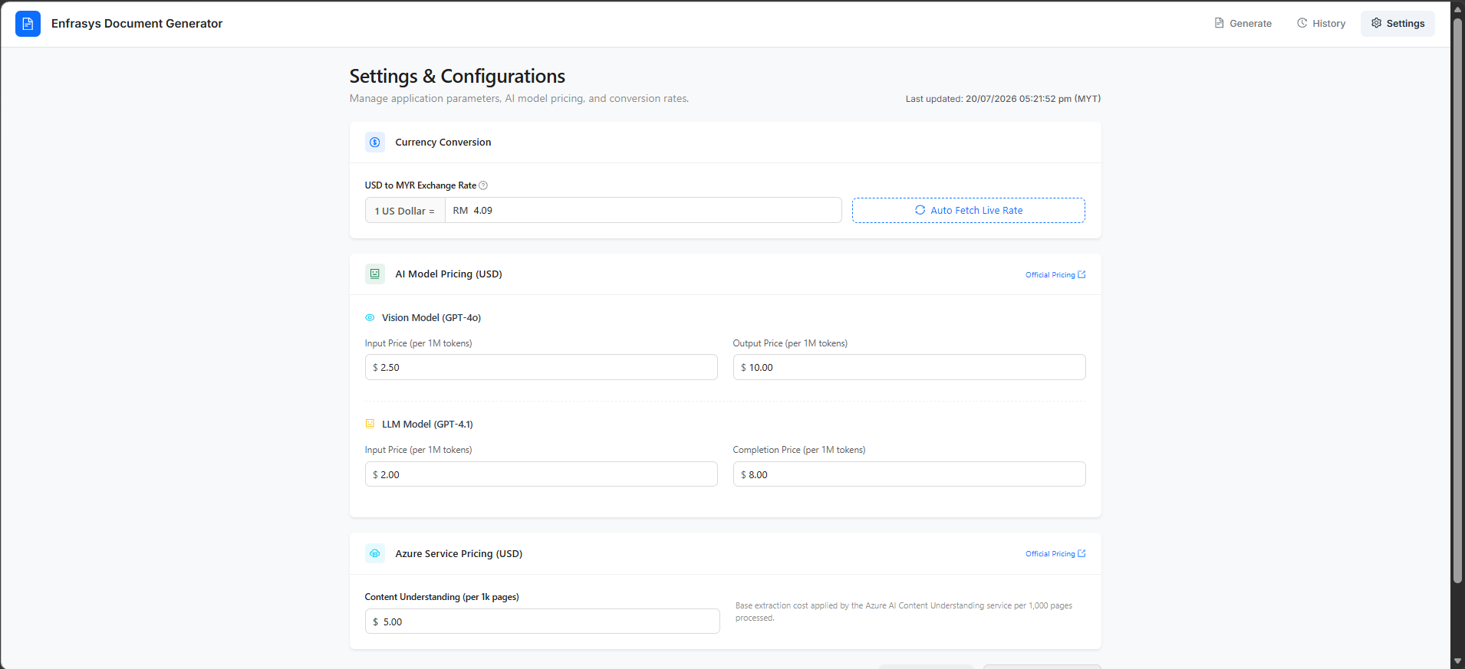

Step 2: Update the Conversion Rate from USD to MYR.
As the USD to MYR exchange rate changes periodically, the Currency Conversion section allows you to update the exchange rate used for cost calculations. You can manually enter the latest USD to MYR exchange rate in the provided input field.
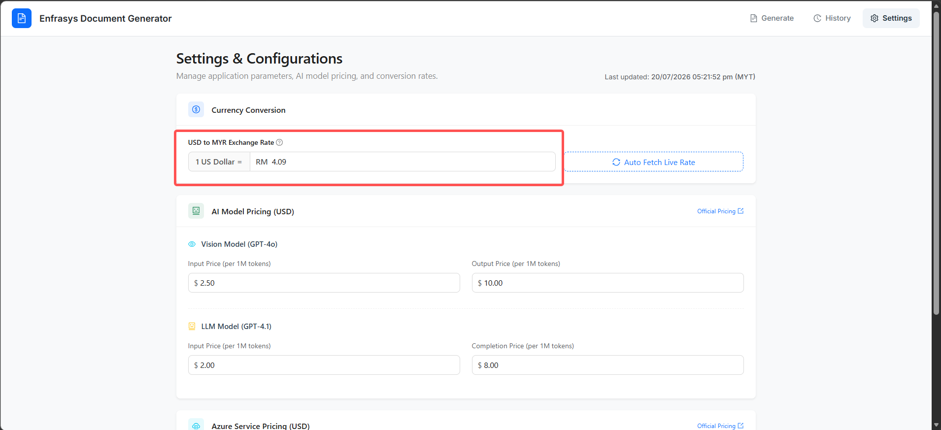
Alternatively, click Auto Fetch Live Rate to automatically retrieve the latest exchange rate and populate the field without requiring manual input.
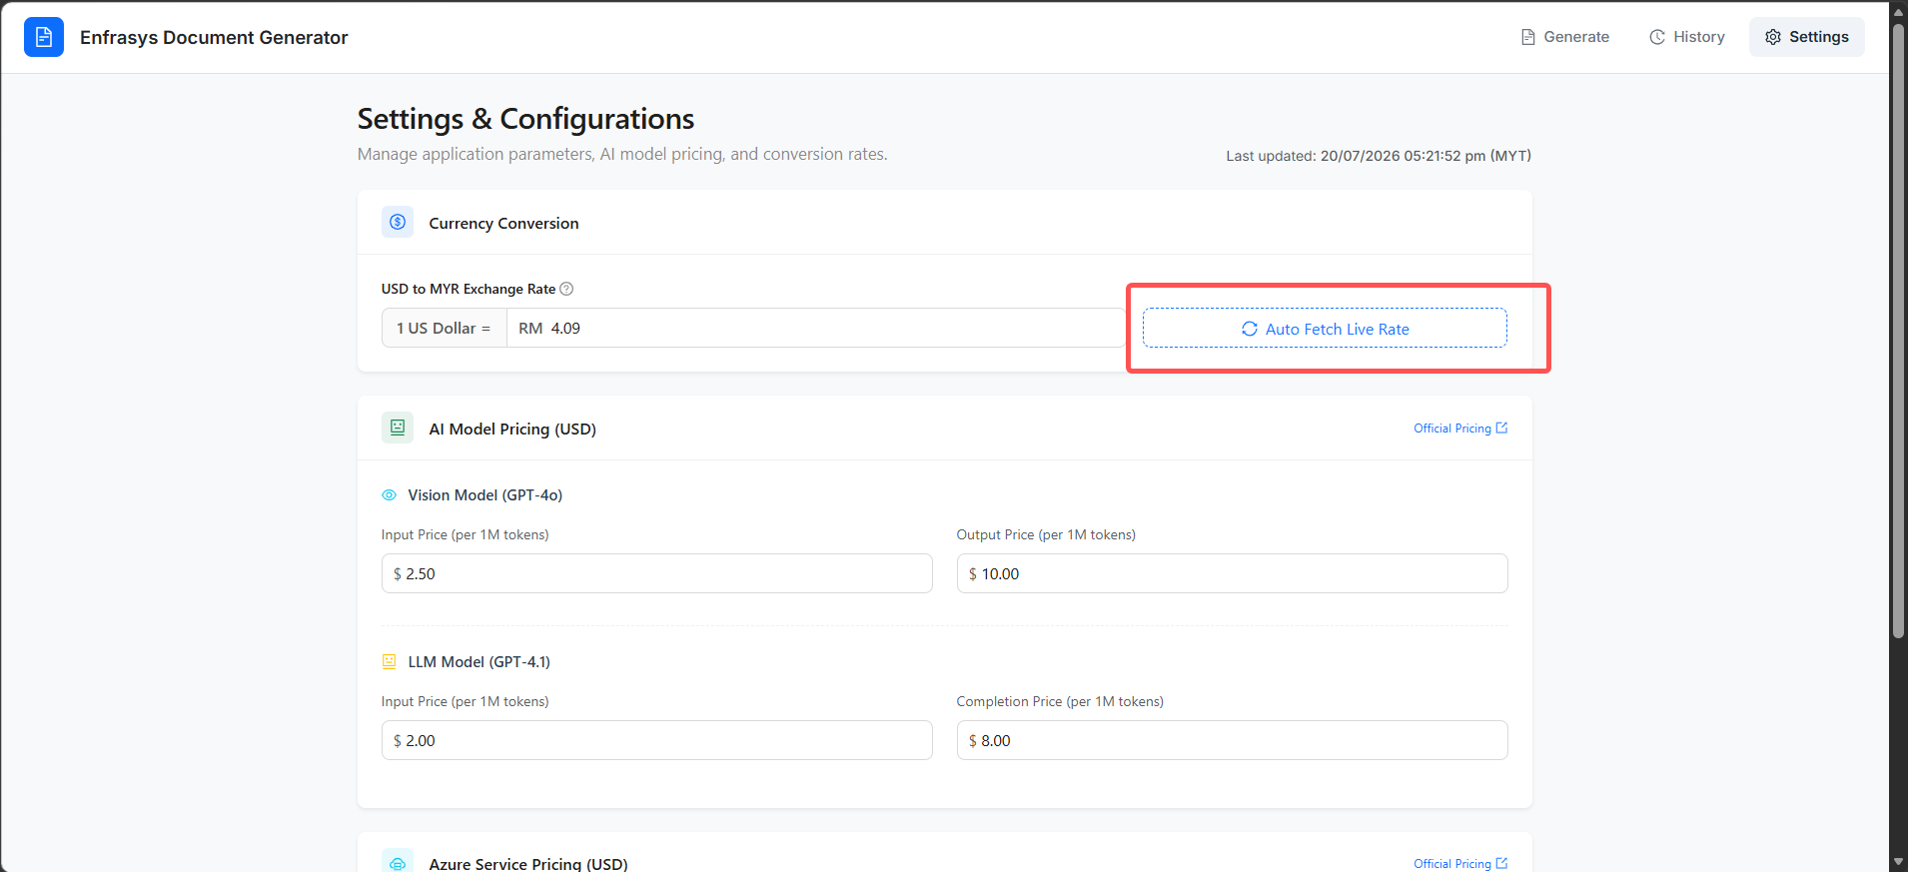

Step 3: Update the AI Model Pricing and Azure Service Pricing (USD)
Microsoft AI model pricing may change over time as new pricing updates are introduced. The AI Model Pricing (USD) section allows you to update the pricing values used for cost estimation. As the application currently uses GPT-4o and GPT-4.1, you may update the corresponding input and output token pricing (per 1 million tokens) based on the latest Microsoft pricing.
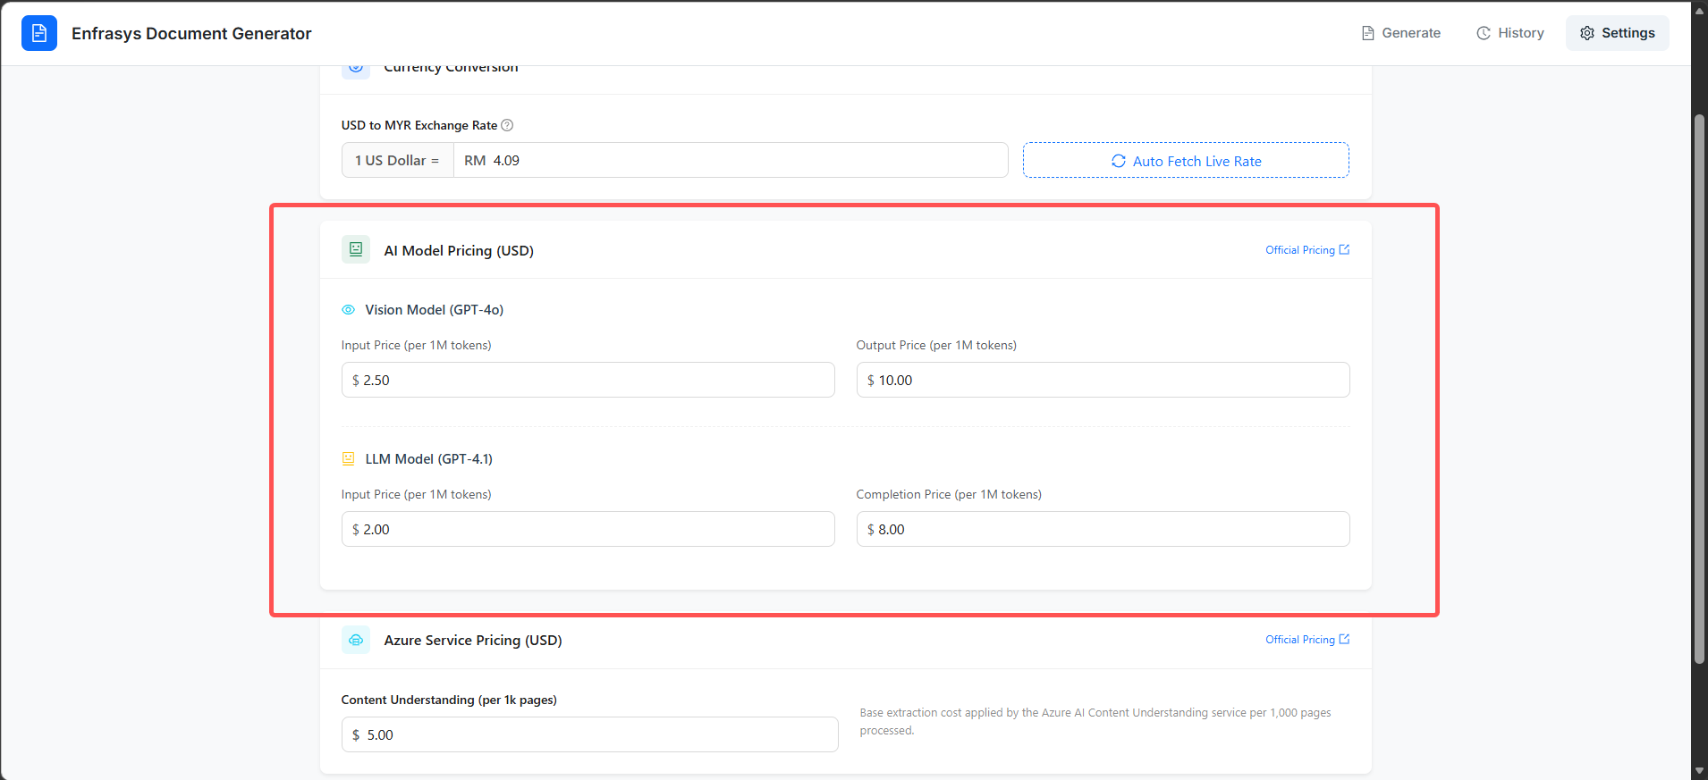
To verify the latest Microsoft pricing, click Official Pricing to open the corresponding pricing page.
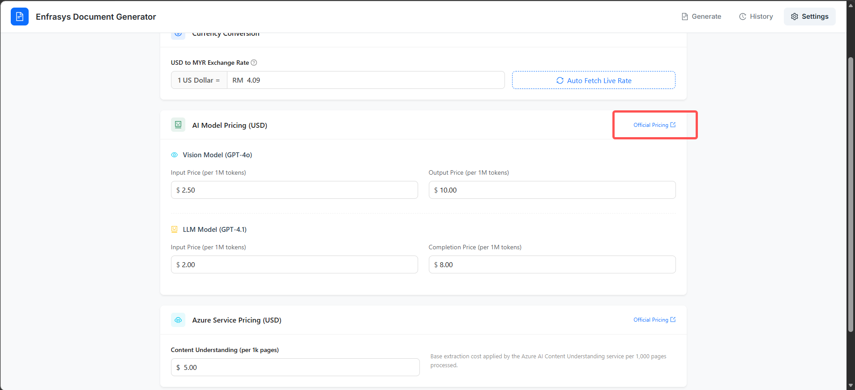

Azure service pricing may also change over time depending on Microsoft's pricing updates. The Azure Service Pricing (USD) section allows you to update the Azure Content Understanding pricing (per 1,000 pages) according to the latest published pricing.
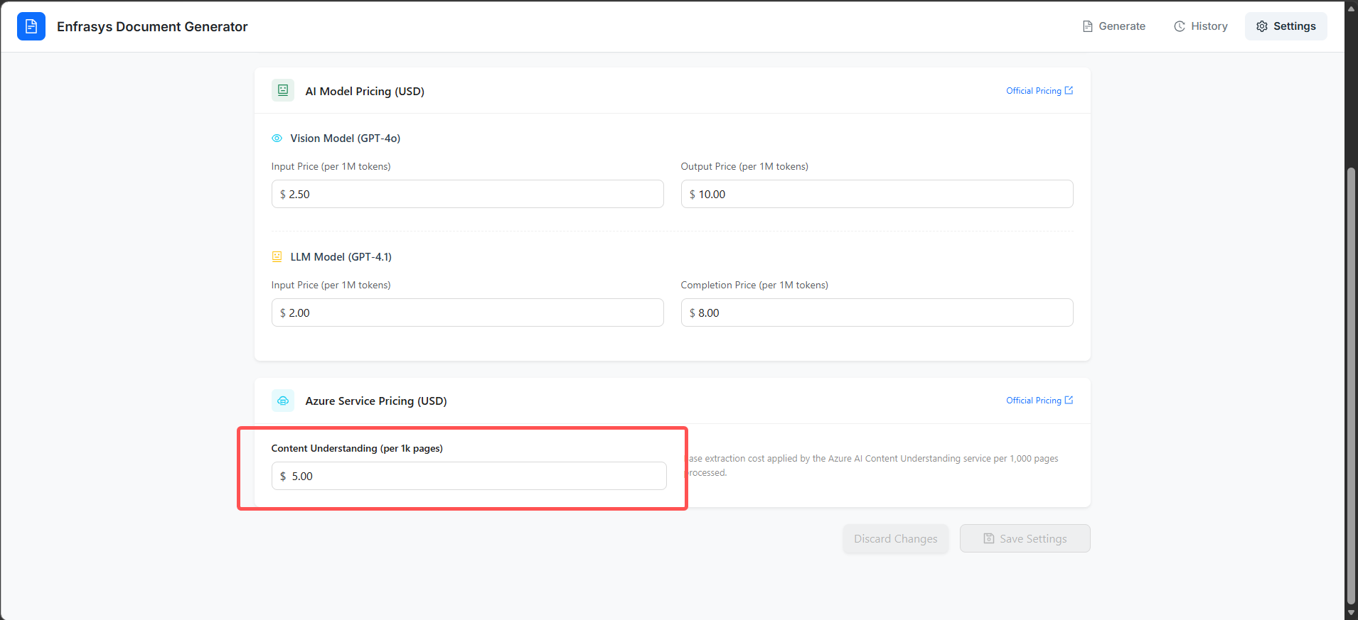

Step 4: Save Changes or Discard Changes
After reviewing your changes, click Save Settings to apply and save the updated pricing configuration.
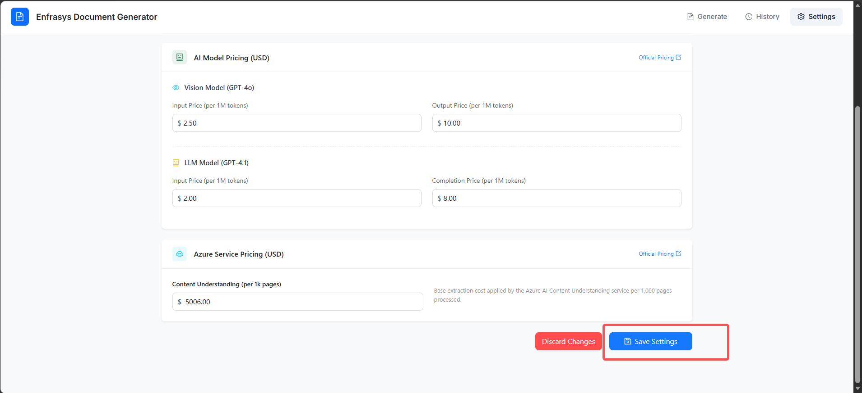
To cancel any unsaved modifications, click Discard Changes to revert all settings to their previously saved values.
